Oreoluwa Ala

STAT 341

Dr. Pawar

August 28, 2024

**Assignment 2**

Variance and standard deviation are data measures that show the variability of data points. Variance quantifies the average squared deviation of each data point from the mean, showing how spread out the values are. Still, it is expressed in the squared units of the data, which can make interpretation more complex.

The formula is:  
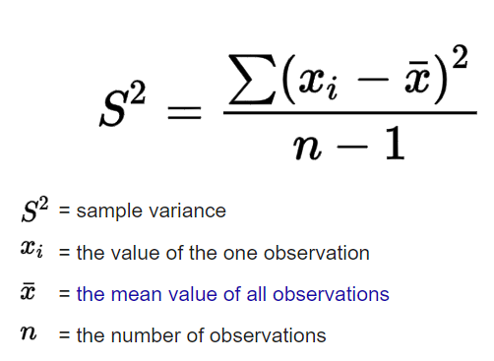

Standard deviation, on the other hand, is the square root of the variance. While variance is helpful for specific statistical calculations and theoretical understanding, standard deviation is often preferred in practical applications because it is directly comparable to the data values.

The formula is:  
